## Software tools:

Jupyter notebook

## Important libraries used:

Numpy

Pandas

Matplotlib

Sklearn

## Description of code:

1. Important libraries were imported.
2. Data from covid-19 csv file was fetched using pandas library.
3. Data was analyzed and preprocessed.
4. Visualize the plots of corona cases with respect to days for each country.
5. The countries with less than 10 cases were removed.
6. The images of these plots were saved in a directory.
7. Features from these images were extracted.
8. Features were normalized and dimensionality of data was reduced by using PCA in order to reduce the computation time.
9. Features array was fed to k means clustering algorithm and average key features were identified.
10. Data was trained using linear regression and isotonic regression to predict future features of those plots.

## Head of CSV file:

The below figure gives an idea of features and data contained in csv file. This data was then preprocessed and fetures were renamed or grouped which makes it easier to perform machine learning on the data.

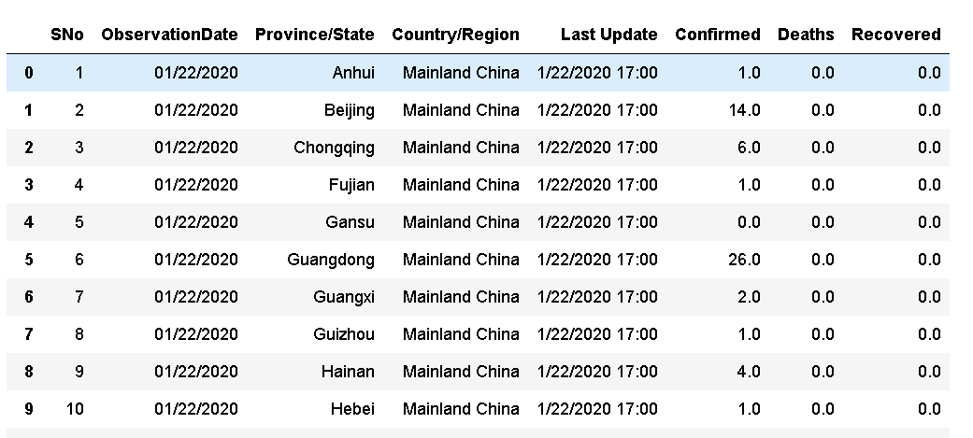

## Corona cases of world:

This figure shows the pattern exhibited by confirmed, recovered and death of corona cases.

## Error plot for linear regression:

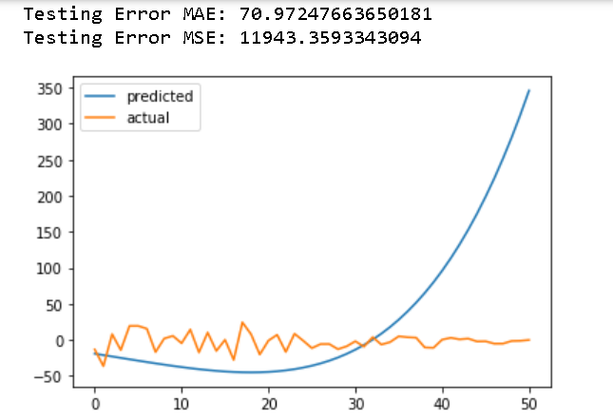

## Error plot for isotonic regression:

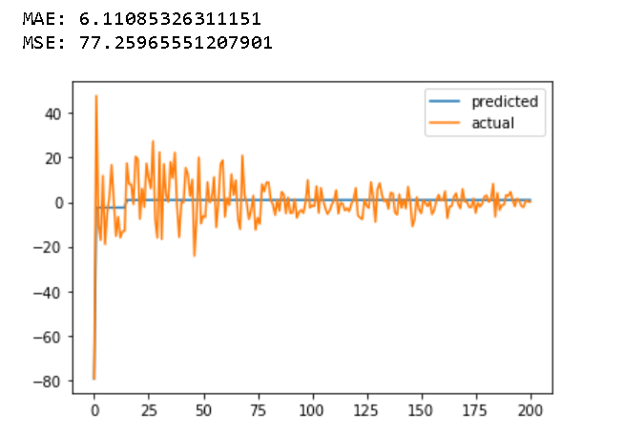

## Sample image for clustering:

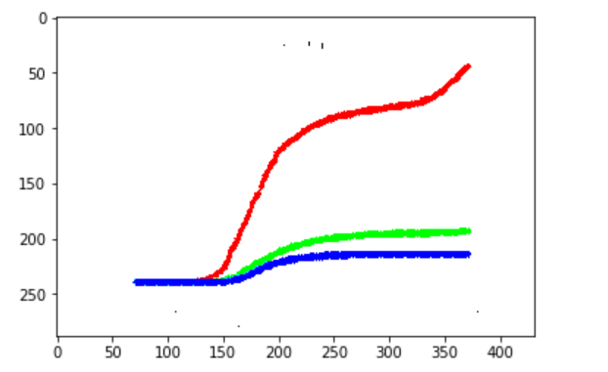

These images tells about the corona cases, deaths and recovered for each country. Features from these images were extracted and then k means clustering was applied to identify few common features. These common features were then trained using regression methods.